**EXPERIMENT 8**

**SAILOR BOAT DATABASE (DDL, DML, DQL, Subquery, Joins, Set operations)**

**Aim:**

1. Create sailors, boats, and reserves.(foreign key)
2. Insert 5 values each table.
3. Display all records.
4. Find the names and ages of all sailors.
5. Find all sailors with ratings above 8.
6. Find sailors name with rating above 7 & age above 25.
7. Display all the names & colors of the boats.
8. Find all the boats with Red colors.
9. Find the names of sailors' who have reserved boat number 103.
10. Find the sids of sailors who have reserved blue boat
11. Find the names of sailors' who have reserved Red boat.
12. Find the colours of boats reserved by some name(provide any name in table).
13. Find the names of the sailors who have reserved at least one boat.
14. Find the names of the sailors who have reserved two different boats.
15. Find the names of sailors who have reserved a Red or a Green boat.(union)
16. Find the names of sailors who have reserved both a Red and a Green boat.
17. Find the names of sailors who have reserved boat 103.(nested query)
18. Find the names of sailors who have reserved red boat.(nq)
19. Find the names of sailors who have not reserved red boat.(nq)
20. Find the names of sailors who have reserved boat number 103.(exists)
21. Find sailors whose rating is better than some sailors called name.
22. Find sailors whose rating is better than every sailor' called name.
23. Find the sailors with highest rating.
24. Find the average age of all sailors.
25. Find the average age of sailors with a rating of 10.
26. Count the number of sailors.
27. Count the number of different sailor ratings.
28. Find the name and age of the oldest sailor.
29. Find the names of the sailors who are older than the oldest sailor with a rating of 10.
30. Find the age of youngest sailor for each rating level.
31. Find the age of the youngest sailor who is eligible to vote (i.e., is at least 18 years old) for each rating level with at least two such sailors.
32. For each red boat, find the number of reservations for this boat.
33. Find all sailors name according to names.
34. Find all sailors details according to rating.
35. Find all sailors details according to rating(highest first) if ratings are same then according to age(youngest first).

1.

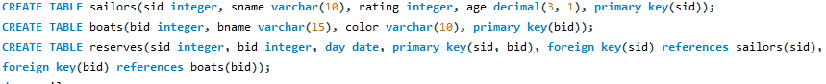

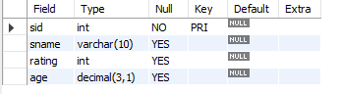

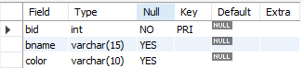

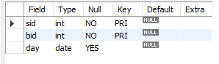

2.

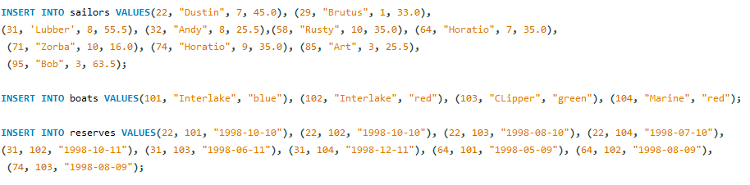

3.

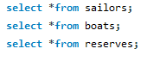

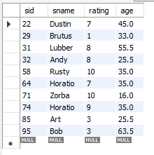 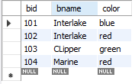 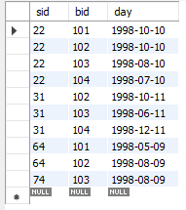

4.



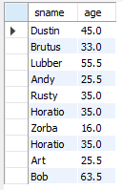

5.



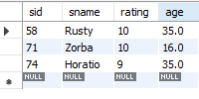

6.



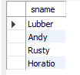

7.



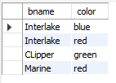

8.



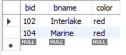

9.



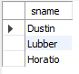

10.



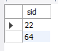

11.



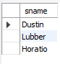

12.



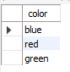

13.



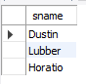

14.



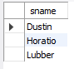

15.

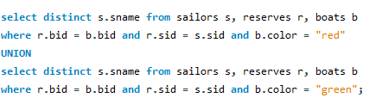

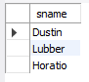

16.



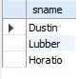

17.



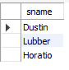

18.

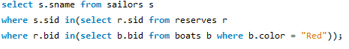

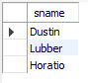

19.

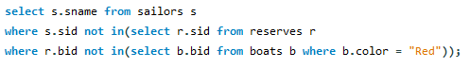

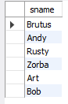

20.



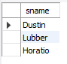

21.



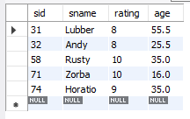

22.



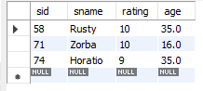

23.



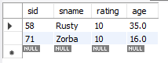

24.



C:\Users\Harinigannamani\Desktop\DBMS Lab\sailors\24.PNG

25.



C:\Users\Harinigannamani\Desktop\DBMS Lab\sailors\25.PNG

26.



C:\Users\Harinigannamani\Desktop\DBMS Lab\sailors\26.PNG

27.



C:\Users\Harinigannamani\Desktop\DBMS Lab\sailors\27.PNG

28.



C:\Users\Harinigannamani\Desktop\DBMS Lab\sailors\28.PNG

29.



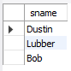

30.



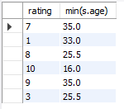

31.



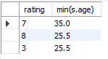

32.



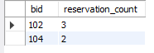

33.



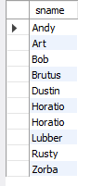

34.



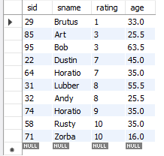

35.



